**Overview:** In today’s lab, you will be building, calibrating, and using simple acoustic sensors to explore how sound is used in seafloor mapping applications. Work in lab groups of 3-4 students to complete this assignment.

**Part 1: Build a simple acoustic sensor**

The acoustic sensor you will use in this lab (HCSR-04) transmits sound and measures time elapsed until receiving it back. Using the speed of sound in the medium (e.g. in air, freshwater, or seawater) the sensor can calculate how far away an object or surface is just by measuring the time between sending out a sound, and receiving the echo. In this lab, we will just use the speed of sound in air (343 m/s).

**Materials needed:** acoustic sensor, four jumper wires, Pyboard microcontroller, USB cable, laptop

1. Connect the acoustic sensor to the microcontroller using jumper wires as shown below:

|  |  |
| --- | --- |
| VCC (distance sensor) → V+ (Pyboard) | GND (distance sensor) → GND (Pyboard) |
| TRIG (distance sensor) → X10 (Pyboard) | ECHO (distance sensor) → X9 (Pyboard) |

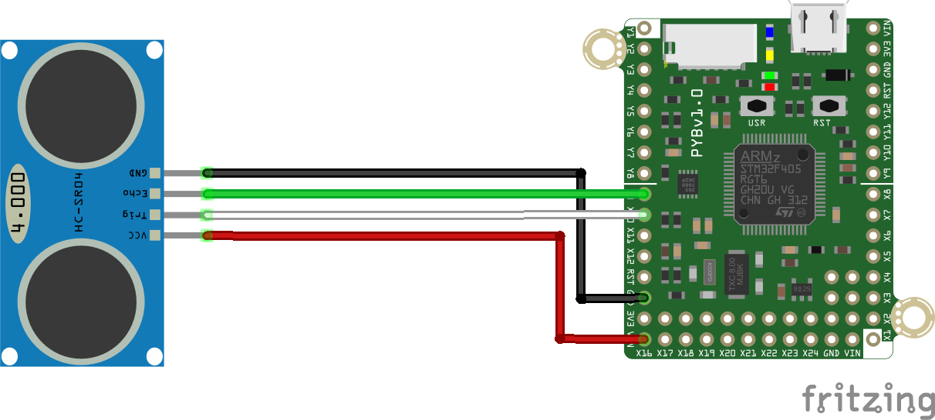

1. Connect the Pyboard to a laptop using the microUSB-USB cable. It should come up as a flashdrive. **When you are ready to unplug your Pyboard after the lab, eject it properly just as you would a flashdrive.**
2. In Google Chrome, launch the Beagle Term app and connect to your sensor. You can find this by searching the Chrome store or by searching “Beagle Term” in Google. This app lets you directly communicate with a microcontroller like the Pyboard you just attached the acoustic sensor to.

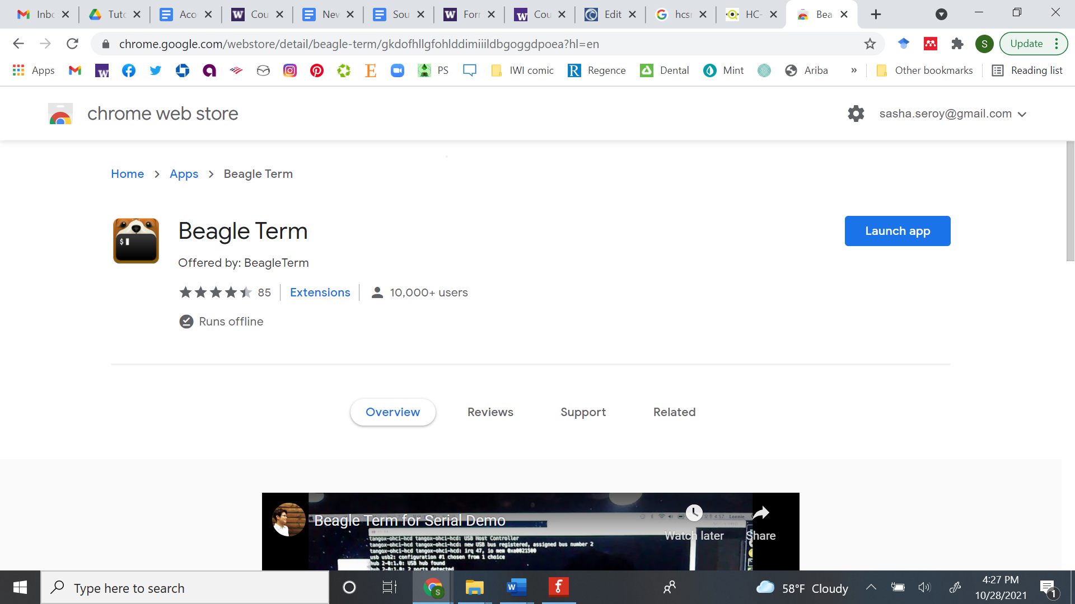

1. Beagle Term should automatically detect the settings you need. Click ‘Connect’ and make sure to click inside the window and press Enter. *Note: If using a Mac, the Port may not automatically detect and you may need to try a few different ports in the drop down menu until you find the correct one that enables you to connect.*

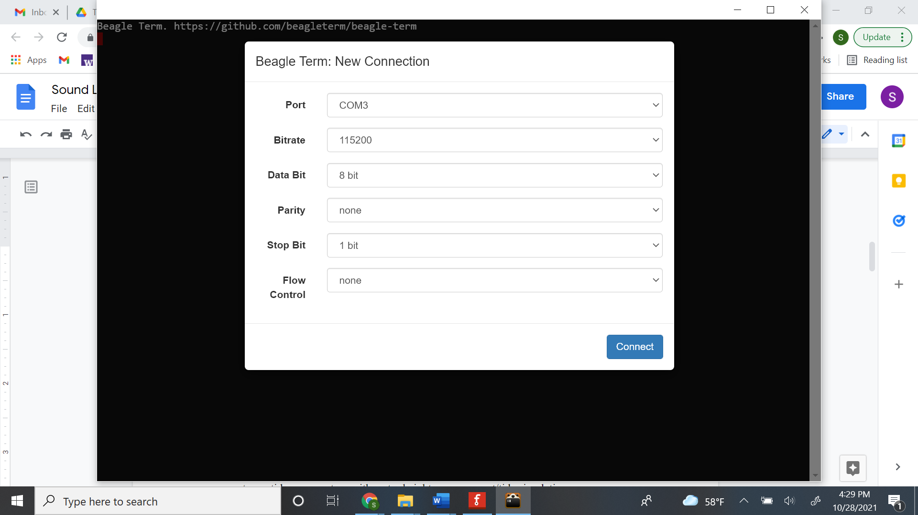

1. When you connect, the screen should look like the image below. The rectangular cursor after >>> indicates you are ready to type code. If you do not get this welcome screen use Ctrl+D to refresh the session.

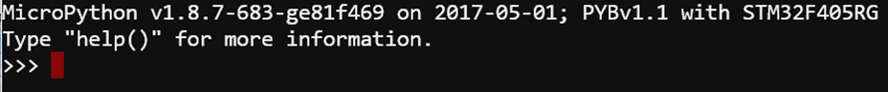

1. In Beagle Term, type the following command and hit Enter to load the necessary function which will enable you to collect distance measurements. This command loads the function **read_distance** from the **distance_sensor** library on the Pyboard.



1. To get a distance measurement (in mm), use the read_distance function you just loaded by typing **read_distance()** and then hit Enter. A distance reading should print on the line below. To take another measurement, hit the up arrow to repeat the previous command without retyping it.

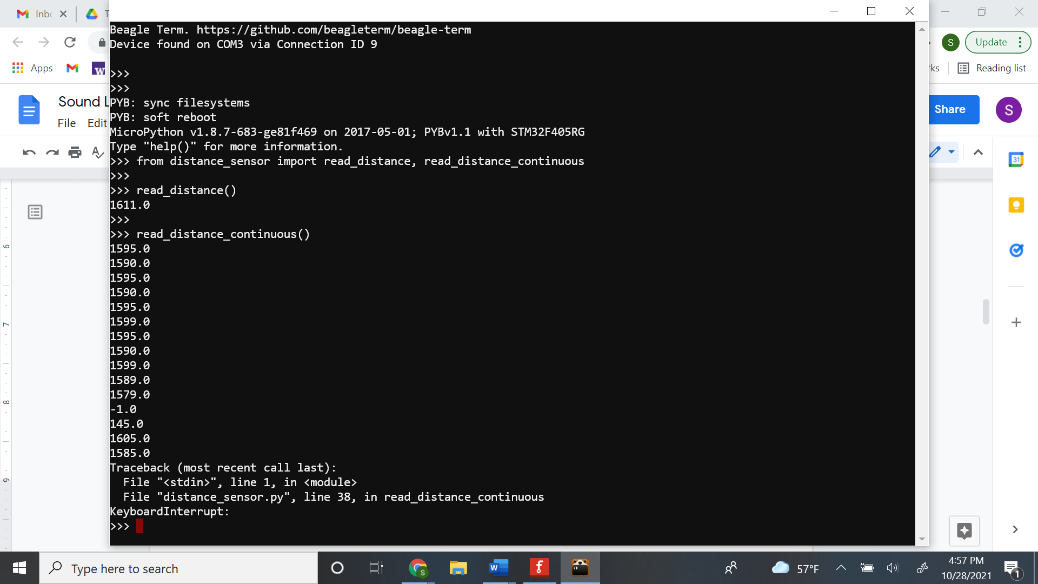

Test out your sensor by moving your hand closer to the sensor and then take a reading. Then move your hand and farther away and take another reading. Observe how the distance detected from your hand to the sensor changes.

**Part 2: Calibrate the acoustic sensor (40pts)**

**Materials needed:** Constructed acoustic sensor, ruler, index card

You will now assess the accuracy of the acoustic sensor you just built. This is known as calibration. To calibrate an instrument, you compare against a known standard. Since your sensor measures distance acoustically, you can compare it to a ruler (a known standard of distance).

1. Place a ruler on the table with the distance sensor set at zero 0 mm.
2. Place an index card 5cm (50mm) away from the sensor and take 5 replicate readings. Record readings in the table below and calculate the mean distance based on your 5 readings. Repeat the process for each of the distances listed below. (12pts)

|  |  |  |  |  |  |  |
| --- | --- | --- | --- | --- | --- | --- |
| **Ruler**  **distance (mm)** | **Sensor Distance 1 (mm)** | **Sensor Distance 2 (mm)** | **Sensor Distance 3 (mm)** | **Sensor Distance 4 (mm)** | **Sensor Distance 5 (mm)** | **Mean Distance (mm)** |
| 50 |  |  |  |  |  |  |
| 100 |  |  |  |  |  |  |
| 150 |  |  |  |  |  |  |
| 200 |  |  |  |  |  |  |
| 250 |  |  |  |  |  |  |
| 300 |  |  |  |  |  |  |

1. Assess the precision of your acoustic sensor using your distance data from 200mm. Recall that calculating the standard deviation of your measurements will give you a measure of precision. Show your work. (4pts)

|  |  |
| --- | --- |
| **Standard deviation** **(σ) =** measure of the spread of a set of data points |  |
| *n* = number of values in set = each value from the set | |

1. What does this mean about how repeatable or precise your distance measurements are? (2pts)
2. Create a calibration curve for your acoustic sensor. This will help you assess the accuracy of your sensor. Accuracy is a measure of how close your sensor readings are to the true value (ruler measurement). To create the calibration curve, make a graph of the ruler distance vs. the mean measured distance using the six points from your table above. Use the Excel template (Tab 1) to help you. Open the spreadsheet locally in Excel, not in Google Sheets to preserve the functionality. Attach the Excel file with completed graph to your assignment submission. (12pts)
3. Report the equation of the trendline for your calibration. What does the slope mean about the calibration? What does the intercept mean about the calibration? (5pts)
4. Using your answers above, how accurate do you think your acoustic sensor is? (3pts)
5. Are there any differences in your sensor’s accuracy when reading short vs. long distances? How do you know? (2pts)

**Part 3: Use the acoustic sensor to map the seafloor (48pts)**

In this part you will use your sensor to measure the height of the seafloor along a transect using a Bathymetry Box. Inside the Bathymetry Box is a replica of a seafloor feature you will try to map using your acoustic sensor. This is analogous to how oceanographers map seafloor features from a ship on the surface.

1. Get a Bathymetry Box and identify the measuring tape along the top of it. This will help you plan out where to take distance measurements.
2. Insert the acoustic sensor facing downward into the frame which will slide along the top of the box.
3. Take distance measurements every three inches and record them in a table. Like you did in Part 2, take 5 replicate readings at each sampling position, and calculate the mean. (8pts)

|  |  |  |  |  |  |  |
| --- | --- | --- | --- | --- | --- | --- |
| **Length along transect (inches)** | **Sensor Distance 1 (mm)** | **Sensor Distance 2 (mm)** | **Sensor Distance 3 (mm)** | **Sensor Distance 4 (mm)** | **Sensor Distance 5 (mm)** | **Mean Distance (mm)** |
| 1” |  |  |  |  |  |  |
| 4” |  |  |  |  |  |  |
| 7” |  |  |  |  |  |  |
| 10” |  |  |  |  |  |  |
| 13” |  |  |  |  |  |  |

1. Now increase the spatial resolution of your measurements. Take distance measurements as you did above every inch and record them in the table below. (16pts)

|  |  |  |  |  |  |  |
| --- | --- | --- | --- | --- | --- | --- |
| **Length along transect (inches)** | **Sensor Distance 1 (mm)** | **Sensor Distance 2 (mm)** | **Sensor Distance 3 (mm)** | **Sensor Distance 4 (mm)** | **Sensor Distance 5 (mm)** | **Mean Distance (mm)** |
| 1” |  |  |  |  |  |  |
| 2” |  |  |  |  |  |  |
| 3” |  |  |  |  |  |  |
| 4” |  |  |  |  |  |  |
| 5” |  |  |  |  |  |  |
| 6” |  |  |  |  |  |  |
| 7” |  |  |  |  |  |  |
| 8” |  |  |  |  |  |  |
| 9” |  |  |  |  |  |  |
| 10” |  |  |  |  |  |  |
| 11” |  |  |  |  |  |  |
| 12” |  |  |  |  |  |  |
| 13” |  |  |  |  |  |  |

**When you are ready to unplug your Pyboard after the lab, eject it properly just as you would a flashdrive. Do not just unplug it!!!**

1. Create a graph which combines the data from the above two tables. Plot length along transect vs. the mean depth calculated using your acoustic sensor. Use the Excel Template (Tab 2) to help you. Open the spreadsheet locally in Excel, not in Google Sheets to preserve the functionality. Attach the Excel file with completed graph to your assignment submission. (12pts)
2. How did increasing the resolution of your measurements affect your ability to characterize the bathymetry? Provide an example from your graph. (5pts)
3. What feature(s) could you identify from your acoustics measurements? (3pts)
4. What would be the ideal spatial resolution to sample the transect you sampled? Why? (2pts)

**Reflection questions (12pts)**

1. What are the overall benefits of using these acoustic tools? (3pts)
2. What are the overall limitations of using these acoustic tools? (3pts)
3. Over what time and space scales could these acoustic tools be helpful to observing the environment? (4pts)

**Feedback:** What did you think of this lab? What did you learn from it? Did you enjoy it? What can be improved? (2 pts)